A000-Asia-Iraq-Shanidar-*Homo sapiens neanderthalensis*-230,000 BP

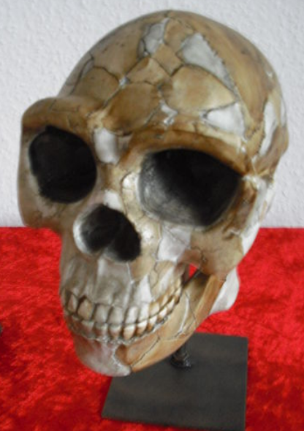

**Formal Label:** *Homo sapiens neanderthalensis*-230,000 BP

Case No. 1

**Display Description:** This Neanderthal skull is a reconstruction of one from northern Iraq (Shanidar).

The type specimen for H. neanderthalensis is [Neanderthal 1](http://efossils.org/page/boneviewer/Homo%20neanderthalensis/Neanderthal%201) was discovered by miners in Aug. 1856 in Felderhofer Grotto, Düsseldorf, in the Neander Valley in Germany. This specimen dates between 40 Ka and 50 Ka but the time range of Neanderthals in general is 122 Ka-40 Ka, therefore, Homo neaderthalensis lived in Western Asia and Europe at the same time as *Homo sapiens sapiens* with which it interbred.

Neanderthal males had cranial capacities ca 1600 cm3 and females ca 1300 cm3 which are larger than modern *Homo sapiens sapiens* (the 1250–1400 cm3) The height of males was ca 164–168 cm (65–66 in) and females ca 152–156 cm (60–61 in). Neanderthals interbred with *Homo sapiens sapiens* in three episodes: 1) ca 100,000 BP with ancestors of non-African modern *Homo sapiens sapiens* after their leaving Africa; and most intensively from 60,000 BP to 40,000 BP; 2) with ancestral Melanesians that had branched off and had interbred with Denisovans); and 3) with ancestors of East Asians.

**Accession Number:**

**LC Classification: GN285**

**Date or Time Horizon:** 230,000 BP-40,000 BP

**Geographical Area:** Europe

**Map, GPS coordinates:**

**Cultural Affiliation:**

**Medium:** museum replica in resin.

**Dimensions:**

**Weight:**

**Condition: museum replica.**

**Provenance:**

**Discussion:**

Neanderthals were short and stocky with short arms and legs and a very robust musculature. Their brains were fully modern in size. The skull was different from *Homo sapiens sapiens,* having a thick cranial vault, with prominent brow ridges, inflated cheeks and a protruding prominence at the lower back of the skull (occipital torus). The nasal aperture was wide, perhaps to help breathing in cold, dry air and heating it fast, and the jaw and incisors were large and probably adapted to tearing and chewing vegetable fibers as well as meat. Neanderthals reached physical maturity at around age 15 years, and most died before 40 with arthritis and numerous injuries sustained from hunting large Pleistocene animals.

**References:**

Brahic, Catherine. "Humanity's forgotten return to Africa revealed in DNA", *The New Scientist* (February 3, 2014).

Fu, Q., Li, H.; Moorjani, P.; Jay, F, et alii. 23 October 201**4. "**Genome sequence of a 45,000-year-old modern human from western Siberia,"Nature, 514 (7523): 445–449.

Henry, A. G.; A. S. Brooks, D. R. Piperno. 2010. “Microfossils in calculus demonstrate consumption of plants and cooked foods in Neanderthal diets (Shanidar III, Iraq; Spy I and II, Belgium),” Proceedings of the National Academy of Science, 108 (2): 486–491.

“Neanderthals mated with modern humans much earlier than previously thought, study finds: First genetic evidence of modern human DNA in a Neanderthal individual,” *ScienceDaily.* 17 February 2016.

Rincon, Paul 2010-05-06. “Neanderthal genes ‘survive in us,’” *BBC News.*

Sánchez-Quinto, F; Botigué, LR; Civit, S; Arenas, C; Avila-Arcos, MC; Bustamante, CD; Comas, D; Lalueza-Fox, C (October 17, 2012). "North African Populations Carry the Signature of Admixture with Neandertals," *PLOS ONE.* **7**: e47765.

Sankararaman, S ., S .Mallick, N. Patterson, D. Reich. 2016. “The combined landscape of Denisovan and Neanderthal ancestry in present-day humans,” *Current Biology*, *26*(9): 1241-1247.